**Lab Report #01**

**Experiment Name #** Linux set up ( Linux mint).

**Aim and Objective:**

The purpose of the experiment is to learn to set up Linux operating system. Also to provide an introduction about Linux environment and compare it’s effectiveness with other operating system.

* To implement Linux operating system.
* To investigate the environment of Linux.
* To realize the effectiveness of Linux OS.
* To perform the various command on Linux OS.

**Experiment Setup:**

To set up Linux by bootable USB device first I installed an software in my pc named as Universal USB installer. Then there I boot the pendrive and install Linux in the pendrive by using the following easy steps:

First agree to the Universal USB Installer agreement:

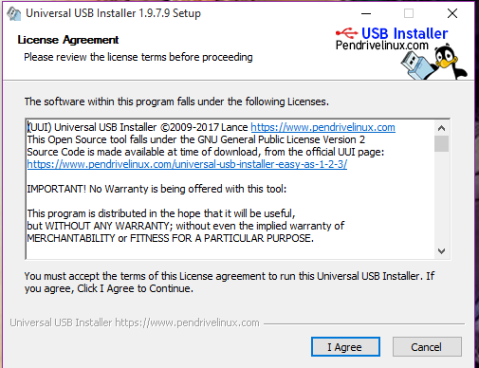

Then after agreeing to the agreement I full fill the required information into the asked options. I select the distribution Linux mint, browse and select the iso file of linux os and select my USB driver ‘SHARNA DAS ’. Then I pressed create option and by clicking yes button I successfully boot my USB drive and installed Linux mint.

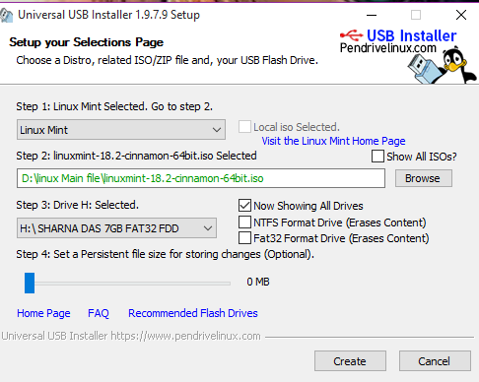

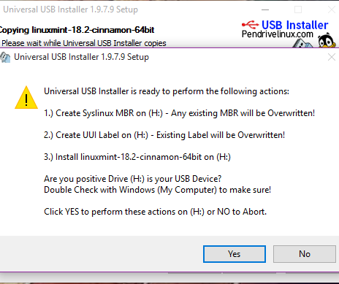

Next I restart my pc and before appearing ASUS I put my USB driver to the USB port and press ‘esc’ button. Then boot page of my pc appear and by pressing start linux mint cinnamon 18.2 version I successfully installed.

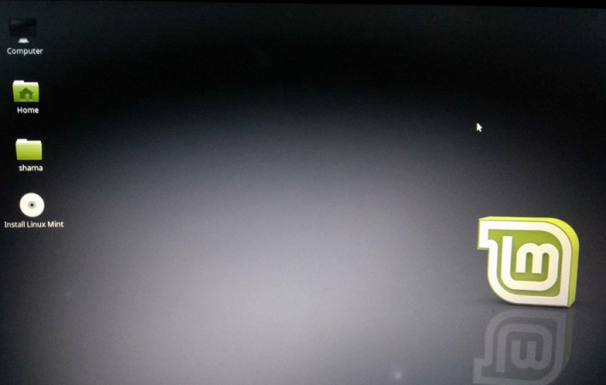

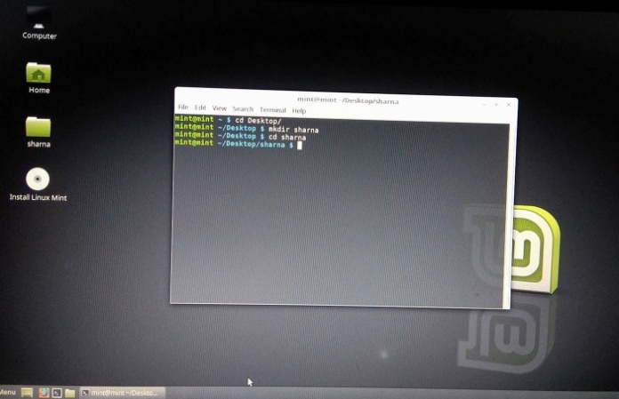

**Conclusion:**

By following those easy steps I successfully installed Linux mint by using bootable USB device. This process is very easy and it is very useful while using two operating systems on one’s device. Linux is very efficient and secure. It will also be used for further experiment.